**JOURNEASE**

**PROJECT THESIS SUBMITTED**

**TO**

**AWH ENGINEERING COLLEGE**

# KUTTIKKATTOOR, KOZHIKODE

**IN PARTIAL FULFILMENT**

**OF THE REQUIREMENTS FOR THE AWARD OF THE**

**DEGREE**

# OF

**Master Of Computer Applications**

## BY

## RIHALA SHIRIN T V



**DEPARTMENT OF COMPUTER APPLICATIONS**

**AWH ENGINEERING COLLEGE KUTTIKKATTOOR,**

## KOZHIKODE

## MAY 2024



**AWH ENGINEERING COLLEGE**

KOZHIKODE

### CERTIFICATE

This is to certify that this thesis entitled “JOURNEASE”submitted herewith is an authentic record of the thesis work done by RIHALA SHIRIN T V (AWH22MCA-2031) under our guidance in partial fulfillment of the requirements for the award of Master of Computer Applications from APJ Abdul Kalam Technological University during the academic year 2023.

### Mrs.Sruti Sudevan Mrs.Sruti Sudevan

Assistant Professor Assistant Professor

Dept. of Computer Applications Dept. of Computer Applications

Head of the department Project guide

**External Examiner Internal Examiner**

## ACKNOWLEDGEMENT

I express my sincere gratitude to our beloved principal **Dr.Sabeena M V** for providing me an opportunity with the required facilities for doing this project. I express my hearty thanks to **Mrs.Sruti Sudevan**, Head of the department of Computer Applications, **Mrs.Sruti Sudevan,** Assistant Professor for her guidance. I am thankful to all other staff of the MCA department for their encouragement, timely guidance, valuable suggestions and inspiring ideas given throughout this project. I am grateful to my friends for the way they have cooperated, expected me to achieve success and have always stirred my ambition to do the best. Above all, I am grateful to the almighty, who has showered His blessings on me throughout my life and throughout the project.

**RIHALA SHIRIN T V**

## ABSTRACT

JournEase is a user-friendly project designed to simplify the journey planning process. With streamlined features, including user registration, package and resort exploration, and straightforward booking options, it ensures a hassle-free experience. Users can easily provide feedback through reviews and make payments. The system is designed to make communication smooth between different groups, like administrators, agencies, guides, resorts, and users, optimizing tasks for efficient planning. JournEase’s user friendly platform goes beyond basic planning, offering personalized recommendations and easy trip planning customization for a tailored experience. Real time updates keep users informed, while the commitment to smooth communication extends to administrators, agencies, guides, resorts, and fellow travelers. From managing agencies to coordinating with guides and ensuring resorts are ready with a focus on efficiency and satisfaction, JournEase is committed to making the entire journey planning process enjoyable and accessible for all.

# CONTENTS

Page No

1. INTRODUCTION 1
2. SYSTEM ANALYSIS 3
   1. Existing System 4
   2. Proposed System 4
   3. Module Description 5
   4. Sprint 7
   5. User stories 10
3. FEASIBILITY STUDY 11
   1. Economical Feasibility 12
   2. Technical Feasibility 12
   3. Operational Feasibility 12
   4. Behavioral Feasibility 13
   5. Software Feasibility 13
   6. Hardware Feasibilty 13
4. SOFTWARE ENGINEERING PARADIGM 14
   1. Agile Model 15
   2. Scrum 16
5. SYSTEM REQUIREMENT SPECIFICATIONS 19
   1. Software Requirements 20
   2. Hardware Requirements 20
6. SYSTEM DESIGN 21
   1. MongoDB 22
   2. Collections 22
   3. UML Design 24
   4. Use Case Diagram 25
   5. Scenario 27
   6. Sequential Diagram 29
7. SYSTEM DEVELOPMENT 34
   1. Coding 35
8. SYSTEM TESTING AND IMPLEMENTATION 37
   1. Types of Testing 38
9. SYSTEM MAINTENANCE 40
10. FUTURE ENHANCEMENT 42
11. CONCLUSION 44
12. APPENDIX 46
13. BIBILIOGRAPHY 79

# INTRODUCTION

## 

## 1.INTRODUCTION

JournEase is a revolutionary platform designed to revolutionize the journey planning experience. With its user-centric approach, JournEase simplifies the entire process, from registration to booking, and beyond. Offering a wide array of features, JournEase enables users to explore packages and resorts effortlessly, customize their trip according to their preferences, and make secure payments with ease.

One of the key highlights of JournEase is its focus on smooth communication across different stakeholders, including administrators, agencies, guides, resorts, and users. This ensures efficient coordination and optimization of tasks, ultimately leading to a hassle-free planning experience. But JournEase doesn't stop there. It goes beyond basic planning by providing personalized recommendations and trip customization options, ensuring that each journey is tailored to the user's preferences and needs. Real-time updates keep users informed every step of the way, while the platform's commitment to smooth communication fosters collaboration and satisfaction among all involved parties. Whether it's managing agencies, coordinating with guides, or ensuring resorts are prepared, JournEase is dedicated to making the entire journey planning process enjoyable and accessible for everyone. With JournEase, embark on your next adventure with confidence, knowing that every detail has been taken care of for an unforgettable experience.

Furthermore, JournEase is not just a platform for planning vacations; it's a community-driven hub that encourages engagement and interaction among travelers. Users can share their experiences, recommendations, and tips, creating a vibrant ecosystem of like-minded adventurers. Whether seeking travel inspiration, seeking advice on destinations, or connecting with fellow travelers, JournEase fosters a sense of belonging and camaraderie. By harnessing the collective wisdom of its user base, JournEase elevates the journey planning experience from mere logistics to a shared adventure filled with shared memories and enriching experiences. Join the JournEase community today and embark on a journey of discovery, connection, and endless possibilities.

**SYSTEM ANALYSIS**

## 

## 2.SYSTEM ANALYSIS

### 2.1 Existing system

Right now, planning a trip can be a bit complicated for users. The usual travel platforms resorts. Communication between different groups, like administrators, agencies, guides, resorts, and users, is not very smooth, causing problems in coordinating tasks. This makes planning a trip less enjoyable and more difficult. To fix this, we need a simpler and more userfriendly approach to make journey planning easier for everyone. Now, with the added limitation of not being able to choose resorts, opt for health assistants or guides, or select adventure options, trip planning becomes even more cumbersome and less enjoyable. To overcome these challenges, we urgently require a simpler and more intuitive approach to journey planning that caters to the needs of all users.

### 2.2 Proposed system

The proposed system of JournEase is a server based web app designed to

make signing up, exploring packages, and booking resorts easy for everyone. Communication between administrators, agencies, guides, resorts, and users is streamlined, ensuring smooth coordination of tasks. This user-centric approach makes journey planning enjoyable and straightforward. JournEase is committed to providing a solution that simplifies the entire process, making it easier for everyone to plan their journeys effortlessly .With JournEase, planning a trip becomes simple and user-friendly.

The proposed system has several advantages:

* Streamlined user interface for easy navigation.
* Simplified registration process for quick sign-up.
* Pre-packaged trip options for hassle-free planning.
* Seamless communication channels for efficient coordination.
* Elimination of resort selection, health assistant or guide options, and adventure choices for a more straightforward experience

### 2.3 Module Description

This project has 5 modules:

**Admin:**

* Login
* Manage agencies
* Manage Resorts
* Manage guides
* View Packages
* View Bookings

**Agency**:

* Registration
* Login
* Manage profile
* Manage Package
* Manage Adventure
* View Resort and send request
* Manage package booking
* View guide and send request
* View feedback from guide
* View photos
* View review from user

**Resort:**

* Registration
* Login
* Manage profile
* Manage booking
* View reviews

### 

**Guide:**

* Registration
* Login
* Manage profile
* Manage request
* Add feedback
* Add photos

**User**:

* Registration
* Login
* Manage profile
* View Package
* View Resort
* View Adventure
* View Notification
* Send payment
* View receipt
* Add review to resort
* Add review to package

### 2.4 Sprint

#### Sprint 1

|  |  |  |  |  |  |
| --- | --- | --- | --- | --- | --- |
| Module | Task | Hours for completion | Expected date of completion | Actual date of completion | Reason for Deviation |
| Admin/Agency/Hotel/Guide/User | Login | 6 hours | 29/01/2024 | 29/01/2024 |  |
| Agency  sa | Manage package booking | 5 hours | 30/01/2024 | 30/01/2024 |  |
| View Guide | 5 hours | 31/01/2024 | 31/01/2024 |  |
| Send request to guide | 5 hours | 01/02/2024 | 01/02/2024 |  |
| View feedback | 5 hours | 02/02/2024 | 02/02/2024 |  |
| View photos | 5 hours | 03/02/2024 | 03/02/2024 |  |
| Add package | 6 hours | 5/02/2024 | 5/02/2024 |  |
| Manage profile | 5 hours | 06/02/2024 | 06/02/2024 |  |
| Registration | 5 hours | 07/02/2024 | 07/02/2024 |  |
| View package | 6 hours | 08/02/2024 | 08/02/2024 |  |
|  | View Hotels | 5 hours | 09/02/2024 | 09/02/2024 |  |
|  | View Adventures | 5 hours | 12/02/2024 | 12/02/2024 |  |
|  | Send request to Resort | 5 hours | 13/02/2024 | 13/02/2024 |  |

#### Sprint 2

|  |  |  |  |  |  |
| --- | --- | --- | --- | --- | --- |
| Module | Task | Hours for completion | Expected date of completion | Actual date of completion | Reason for Deviation |
| Agency  sa | Add adventure | 5 hours | 14/02/2024 | 14/02/2024 |  |
| Manage Adventure | 5 hours | 15/02/2024 | 15/02/2024 |  |
| Add health assistant | 5 hours | 16/02/2024 | 16/02/2024 |  |
| Add Transport | 6 hours | 17/02/2024 | 17/02/2024 |  |
| View default Hotel | 6 hours | 19/02/2024 | 19/02/2024 |  |
| View default adventure | 5 hours | 20/02/2024 | 20/02/2024 |  |
| Manage Package | 6 hours | 21/02/2024 | 21/02/2024 |  |
| View payment | 5 hours | 22/02/2024 | 22/02/2024 |  |
| Admin  sa | Manage agency | 5 hours | 23/02/2024 | 23/02/2024 |  |
| Manage Hotel | 5 hours | 26/02/2024 | 26/02/2024 |  |
| Manage Guide | 5 hours | 27/02/2024 | 27/02/2024 |  |
| View bookings | 5 hours | 28/02/2024 | 28/02/2024 |  |
| View package | 5 hours | 01/03/2024 | 01/03/2024 |  |

#### Sprint 3

|  |  |  |  |  |  |
| --- | --- | --- | --- | --- | --- |
| Module | Task | Hours for completion | Expected date of completion | Actual date of completion | Reason for Deviation |
| Hotel  sa | Registration | 5 hours | 02/03/2024 | 02/03/2024 |  |
| Manage Profile | 5 hours | 06/03/2024 | 06/03/2024 |  |
| Add Facilities | 5 hours | 11/03/2024 | 11/03/2024 |  |
| Manage facilities | 6 hours | 13/03/2024 | 13/03/2024 |  |
| Add room | 6 hours | 15/03/2024 | 15/03/2024 |  |
| Manage room | 5 hours | 16/03/2024 | 16/03/2024 |  |
| Manage bookings | 6 hours | 18/03/2024 | 18/03/2024 |  |
| View Reviews | 5 hours | 20/03/2024 | 20/03/2024 |  |
| Guide  sa | Registration | 5 hours | 22/03/2024 | 22/03/2024 |  |
| Manage profile | 5 hours | 23/03/2024 | 23/03/2024 |  |
| Manage enquiry | 5 hours | 25/03/2024 | 25/03/2024 |  |
| Add feedback | 5 hours | 26/03/2024 | 26/03/2024 |  |
| Add photos | 5 hours | 27/03/2024 | 27/03/2024 |  |
| View feedback | 3 hours | 28/03/2024 | 28/03/2024 |  |
| View photos | 6 hours | 29/03/2024 | 29/03/2024 |  |
| View hotel | 3 hours | 30/03/2024 | 30/03/2024 |  |
| Validation | 3 hours | 30/03/2024 | 30/03/2024 |  |

**Sprint 4**

|  |  |  |  |  |  |
| --- | --- | --- | --- | --- | --- |
| Module | Task | Hours for completion | Expected date of completion | Actual date of completion | Reason for Deviation |
| User  sa | Registration | 5 hours | 01/04/2024 | 01/04/2024 |  |
| Manage profile | 5 hours | 02/04/2024 | 02/04/2024 |  |
| View Package | 6 hours | 03/04/2024 | 03/04/2024 |  |
| View hotel | 5 hours | 05/04/2024 | 05/04/2024 |  |
| View Notification | 6 hours | 06/04/2024 | 06/04/2024 |  |
| View Adventure | 6 hour | 08/04/2024 | 08/04/2024 |  |
| View Transport | 5 hour | 09/04/2024 | 09/04/2024 |  |
| View reviews of agency | 5 hour | 11/04/2024 | 11/04/2024 |  |
| View reviews of hotel | 5 hour | 12/04/2024 | 12/04/2024 |  |
| Add review hotel | 5 hour | 15/04/2024 | 15/04/2024 |  |
| Add review package | 5 hours | 16/04/2024 | 16/04/2024 |  |
| Choose guide,health assistant | 4 hours | 17/04/2024 | 17/04/2024 |  |
| Validation | 3 hours | 17/04/2024 | 17/04/2024 |  |
| View notification | 6 hours | 18/04/2024 | 18/04/2024 |  |
| View default adventure | 3 hours | 19/04/2024 | 19/04/2024 |  |
| View default transport,resort | 5 hours | 19/04/2024 | 19/04/2024 |  |
| User  sa | | Add and view payment | 5 hours | 01/04/2024 | 20/04/2024 |  |

**2.5 User Stories**

This JournEase project have five modules: Admin, Agency, Resort, Guide and Users.

The Admin should be able to Manage Agencies, Manage Resorts, Manage guide, View Bookings of users for the package to agency, View Packages added by the agency

The Agency should be able to Register and Login, they can Manage profile, Manage package, Manage Adventures, View Resort and send request, Manage Package booking, View Guide and send Request, View Feedback from guide, View photos uploaded by guide, View reviews from user

The Guide should be able to Register and Login , Manage profile, Manage Request from agency ,View package details ,Add feedback for the package, Add photos of the trip

The Resort should be able to Register and login ,Manage profile, Manage request from agency, View Reviews

The User Should be able to Register and login, Manage profile, View package, View Resort, View Adventure, View Notification, Send Payment, View Receipt, Add review to resort, Add review to package, view booking

# FEASIBILITY STUDY

## 3.FEASIBILITY STUDY

An analysis of the ability to complete a project successfully, taking into account legal, economic, technological, scheduling, and other factors is considered a feasibility study. Rather than just diving into a project and hoping for the best, feasibility study allows project managers to investigate the possible negative and positive outcomes of a project before investing too much money and time.

### 3.1 Economical Feasibility

The economic analysis is done to determine the benefits and savings that are expected from the candidate system and compare them with costs. Thus, coming to a conclusion on whether the system is economically feasible or not. This system is cost effective as well as time effective, thereby making it economically feasible. This study presents tangible and intangible benefits from the project by comparing the developments and operational costs. The technique of cost benefit analysis is often used as a basis for assessing economic feasibility.

**3.2 Technical Feasibility**

The technical requirements for the system are economic and it does not use additional software. This application is developed using MERN Stack, whose development kit are easily available and free of cost, thus making our system technically feasible. .

### 3.3 Operational Feasibility

### 

This analysis involves how it will work when it is installed and the assessment of political and managerial environment in which it is implemented. The new proposed system is very much useful to the users and there for it will accept broad audience.

### 3.4 Behavioural Feasibility

### 

This analysis involves how it will work when it is installed and the assessment of the political and managerial environment in which it is implemented. People are inherently resistant to change and computers have been known to facilitate change. The new proposed system is very much useful to the users and therefore it will accept a broad audience.

### 3.5 Software Feasibility

### 

Even though this application is developed in a very high software environment, it is also supported by many other environments with minimal changes. The system is fully feasible to be executed on any kind of operating systems and browsers.

### 3.6 Hardware Feasibility

Software can be developed with the existing resources. But the existing resources may or may not be used to produce hardware. If no hardware is newly bought for a project, then software is said to achieve hardware feasibility. The system is hardware-wise feasible because it needs absolutely no new hardware.

.

## SOFTWARE ENGINEERING PARADIGM

### 

### 4.SOFTWARE ENGINEERING PARADIGM

The software engineering paradigm which is also referred to as a software process model or Software Development Life Cycle (SDLC) model is the development strategy that encompasses the process, methods and tools. SDLC describes the period of time that starts with the software system being conceptualized.

#### 4.1 Agile model

Agile SDLC model is a combination of iterative and incremental process models with focus on process adaptability and customer satisfaction by rapid delivery of working software product. Agile Methods break the product into small incremental builds. These builds are provided in iterations. Each iteration typically lasts from about one to three weeks. At the end of the iteration, a working product is displayed to the customer and important stakeholders.

In Agile, the tasks are divided to time boxes (small time frames) to deliver specific features for a release. Iterative approach is taken and working software build is delivered after each iteration. Each build is incremental in terms of features; the final build holds all the features required by the customer.

At the end of the iteration, a working product is displayed to the customer and important stakeholders. Agile model believes that every project needs to be handled differently and the existing methods need to be tailored to best suit the project requirements. In Agile, the tasks are divided to time boxes (small time frames) to deliver specific features for a release.

Agile software development is an umbrella term for a set of frameworks and practices based on the values and principles expressed in the Manifesto for Agile Software Development and the 12 Principles behind it. When user approach software development in a particular manner, it’s generally good to live by these values and principles and use them to help figure out the right things to do given users particular context. One thing that separates Agile from other approaches to software development is the focus on the people doing the work and how they work together. Solutions evolve through collaboration between self-organizing cross-functional teams utilizing the appropriate practices for their context.

In Agile software development, fostering a culture of continuous improvement is paramount. Teams embrace change and adaptability, valuing feedback loops and frequent iterations to deliver high-quality software that meets evolving customer needs. Transparency and open communication are encouraged, allowing for early identification and resolution of issues. By prioritizing individuals and interactions over processes and tools, Agile teams harness the collective expertise and creativity of team members to drive innovation and deliver value effectively. Embracing Agile principles empowers teams to navigate complexity with agility, delivering software that not only meets expectations but also exceeds them, driving success in today's dynamic and competitive landscape.

##### 4.2 Scrum

Scrum is an agile framework for managing knowledge work, with an emphasis on software development. It is designed for teams of three to nine members, who break their work into actions that can be completed within time boxed iterations, called "sprints", no longer than one month and most commonly two weeks, then track progress and re-plan in 15-minute stand-up meetings, called daily scrums.

Scrum is an iterative and incremental framework for managing product development. It defines "a flexible, holistic product development strategy where a development team works as a unit to reach a common goal", challenges assumptions of the "traditional, sequential approach to product development, and enables teams to selforganize by encouraging physical co-location or close online collaboration of all team members, as well as daily face-to-face communication among all team members and disciplines involved.

Scrum is a framework that helps teams work together. Much like a rugby team (where it gets its name) training for the big game, scrum encourages teams to learn through experiences, self-organize while working on a problem, and reflect on their wins and losses to continuously improve.

While the scrum is talking about is most frequently used by software development teams, its principles and lessons can be applied to all kinds of teamwork. This is one of the reasons scrum is so popular. Often thought of as an agile project management framework, scrum describes a set of meetings, tools, and roles that work in concert to help teams structure and manage their work.

Scrum is the most common agile framework, and the one most people start with. Agile practices on the other hand, are techniques applied during phases of the software development lifecycle. Planning poker for example, is a collaborative estimation practice designed to encourage team members to share their understanding of what done means. The process is quite fun, and has proven to help foster teamwork and better estimates. Continuous integration (also known as ci) is a common agile engineering practice where code changes are integrated into the main branch frequently. An automated build verifies changes, leading to a reduction in integration debt and a continually shippable main branch. These practices, like all agile practices, carry the agile label, because they are consistent with the principles in the agile manifesto.

In the project management, scrum, sometimes written scrum or scrum, is a framework for developing, delivering, and sustaining products in a complex environment, with an initial emphasis on software development, although it has been used in other fields including research, sales, marketing and advanced technologies. It is designed for teams of ten or fewer members, who break their work into goals that can be completed within time-boxed iterations, called sprints, no longer than one month and most commonly two weeks. The scrum team assess progress in time-boxed daily meetings of 15 minutes or less, called daily scrums (a form of stand-up meeting). At the end of the sprint, the team holds two further meetings: the sprint review which demonstrates the work done to stakeholders to elicit feedback, and sprint retrospective which enables the team to reflect and improve.

A key principle of scrum is the dual recognition that customers will change their minds about what they want or need and that there will be unpredictable challenges-for which a predictive or planned approach is not suited. As such, scrum adopts an evidencebased empirical approach accepting that the problem cannot be fully understood or defined up front, and instead focusing on how to maximize the team's ability to deliver quickly, to respond to emerging requirements, and to adapt to evolving technologies and changes in market conditions. Many of the terms used in scrum (e.g., scrum master) are typically written with leading capitals (e.g., scrum master) or as conjoint words written in camel case (e.g., scrum master). To maintain an encyclopaedic tone, however, this article uses normal sentence case for these terms-unless they are recognized marks. This is occasionally seen written in all -capitals, as scrum. The word is not an acronym, so this is not correct; however, it likely arose due to an early paper by ken schwaber which capitalized scrum in its title. While the trademark on the term scrum itself has been allowed to lapse, so that it is deemed as owned by the wider community rather than an individual, the leading capital is retained-except when used with other words.

# 

# SYSTEM REQUIREMENT

**SPECIFICATION**

## 

## 5.SYSTEM REQUIREMENTS SPECIFICATION

### 5.1 Software Requirements

### 

One of the most difficult tasks is selecting software, once the system requirement is find out then we have to determine whether a particular software package fits for those system requirements. This section summarizes the application requirement

* Operating System : Windows 7 or above
* Front End : Html, CSS, JavaScript
* Back End : Node JS, Express JS
* IDE : Visual Studio
* Database : Mongo DB

### 5.2 Hardware Requirements

### 

The selection of hardware is very important in the existence and proper working of any of the software. When selecting hardware, the size and capacity requirements are also important. The hardware must suit all application developments**.**

* Processor : Intel core i3 or above
* RAM : 8GB
* HDD : 1 TB

|  |  |
| --- | --- |
|  |  |
|  |  |
|  |  |

|  |  |  |  |  |
| --- | --- | --- | --- | --- |
|  | | |  | |
|  |  | |  | |
|  |  | |  | |
|  |  | |  | |
|  |  | |  | |

**SYSTEM DESIGN**

## 6.SYSTEM DESIGN

System design is the first in the development phase for many engineered products or systems. It may define the process of applying various techniques and principles for the purpose of defining a device, a process or system in sufficient detail to permit its physical realisation.

### 6.1 MongoDB

Database design is the process of producing a detailed data model of a database. This logical data model contains all the needed logical and physical design choices and physical storage parameters needed to generate a design in a data definition language, which can then be used to create a database. The term database design can be used to describe many different parts of the design of an overall database system.

Non-relational model databases, also known as NoSQL databases, are a type of database management system that diverge from the traditional relational model. Instead of relying on tables with predefined schemas and fixed relationships, NoSQL databases use flexible and dynamic data models, such as document-based, key-value, graph, or column-family.

### 6.2 Collections

In MongoDB, a collection is a grouping of MongoDB documents. It is the equivalent of a table in relational databases. Collections exist within databases and can store multiple documents in a structured format. Each document within a collection can have a unique structure, meaning they don't have to follow a rigid schema like in traditional relational databases. This flexibility allows for dynamic and scalable data storage, ideal for applications with evolving data requirements. Collections in MongoDB can be queried using the powerful MongoDB query language, making it a versatile choice for various data models and application needs.

### Project Collection

* adventure
* booking
* enquiry_guide
* facilities
* image
* issues
* package
* request_guide
* resort
* room
* user
* review

**6.3 UML Designs**

The Unified Modelling Language (UML) is indeed a standardized language used for specifying, visualizing, constructing, and documenting software systems, as well as for business modelling and other non-software systems. It encompasses a collection of best engineering practices that have been proven successful in modelling large and complex systems. UML provides a set of graphical notations that allow software developers and other stakeholders to express and communicate the design of software projects effectively. By using UML, project teams can visualize and explore potential designs, communicate design decisions, and validate the architectural design of the software system. UML diagrams serve as a means to represent various aspects of the system being developed. These diagrams can be used to depict the structure of the system, its behaviour , interactions between components, and the overall flow of activities. The graphical nature of UML diagrams makes them intuitive and easier to understand for both technical and non-technical stakeholders involved in the software development process.

UML provides a standardized and widely accepted notation, which promotes consistency and clarity in design documentation. This allows for better collaboration among team members and facilitates the understanding and maintenance of software systems over time. The use of UML in software development can enhance communication, facilitate design exploration, and provide a solid foundation for developing and documenting complex software systems. Furthermore, UML serves as a powerful tool for both analysis and design phases of software development, enabling developers to visualize and model various aspects of a system's architecture, behavior, and structure. By representing concepts such as classes, relationships, and interactions graphically, UML diagrams offer a common language that stakeholders can easily comprehend, regardless of their technical background. This promotes alignment between different project stakeholders, including developers, designers, testers, and business analysts, fostering a shared understanding of the software system throughout its lifecycle. Additionally, the versatility of UML allows teams to tailor their diagrams to suit different needs and levels of abstraction, making it suitable for projects of varying sizes and complexities.

### 

**6.4 usecase diagram:**

**1)**

### 

### 2)

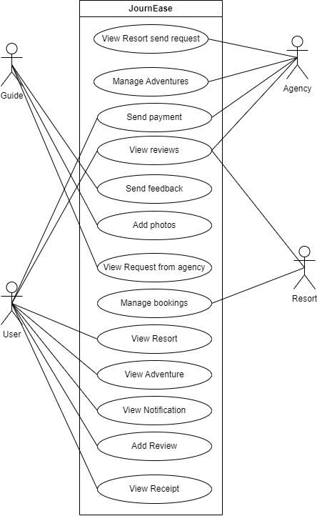

**6.5 Scenarios**

**Admin**

● Login.

* Manage Agencies
* Manage Hotels
* Manage Guides
* View Booking
* View packages

**Agency**

● Registration

* Login
* Manage Package
* Manage Adventure
* View Hotel and send request
* Manage package booking
* View Guide and send request
* Add Health assistant
* View feedback
* View photos
* View Reviews
* Add default Resort
* Add default adventure
* Add Transport
* Add default transport

**Resort**

* Registration
* Login
* Manage profile
* Manage Request
* View Reviews

**Guide**

* Registration
* Login
* Manage profile
* Manage Request
* Add feedback
* Add photos

**User**

* Registration
* Login
* Manage profile
* View package
* View Resort
* View Adventure
* View Notification
* Send Payment
* View Receipt
* Add review to resort
* Add review to package

**6.6 Sequence Diagram**

### Admin

### 

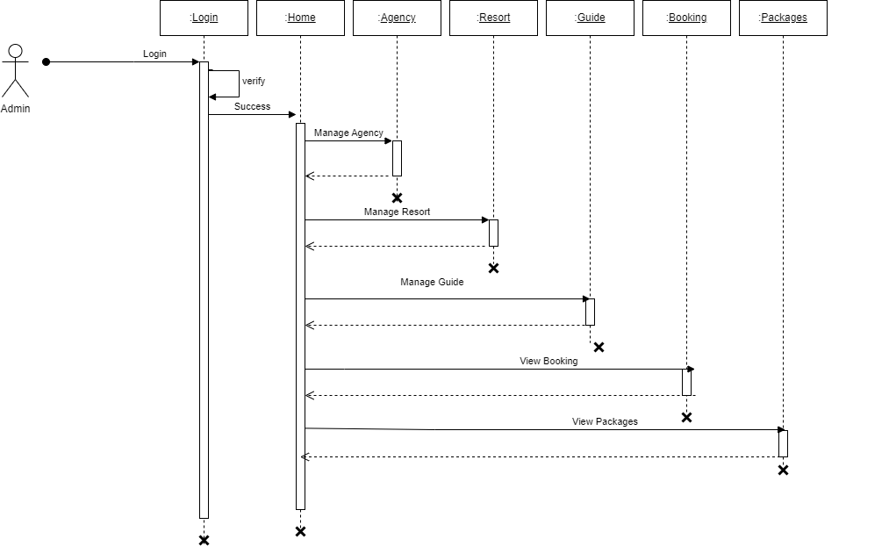

### 

**Agency**

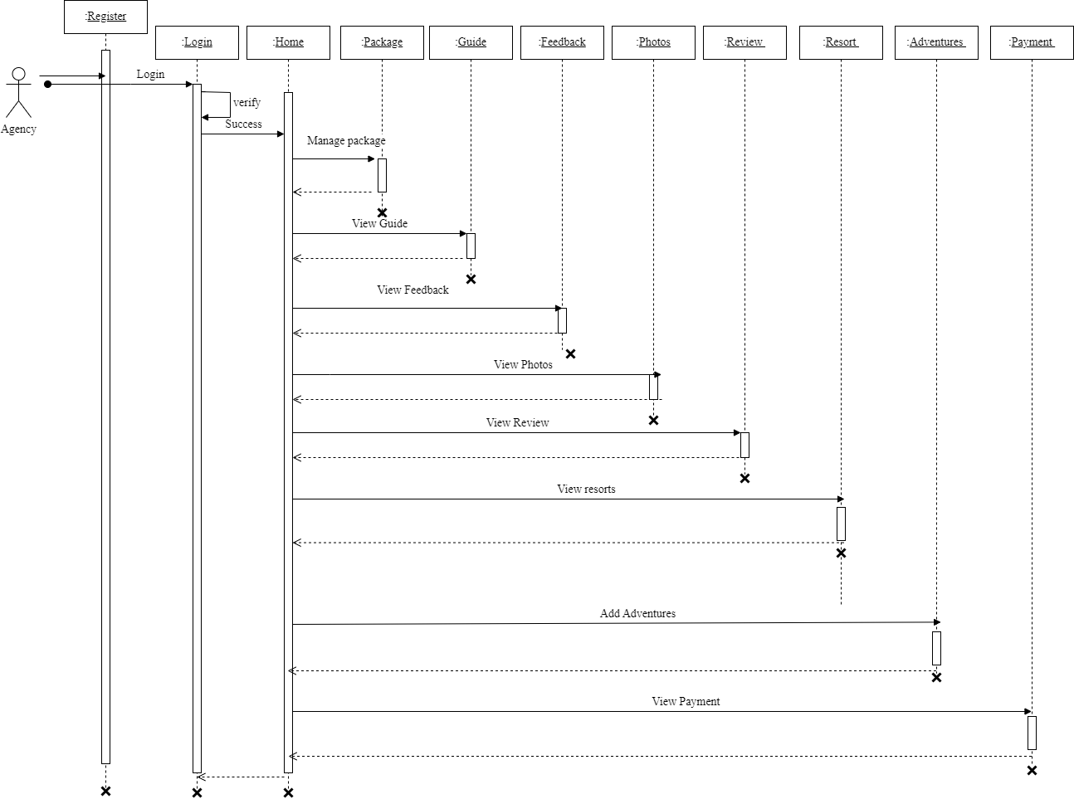

**Resort**

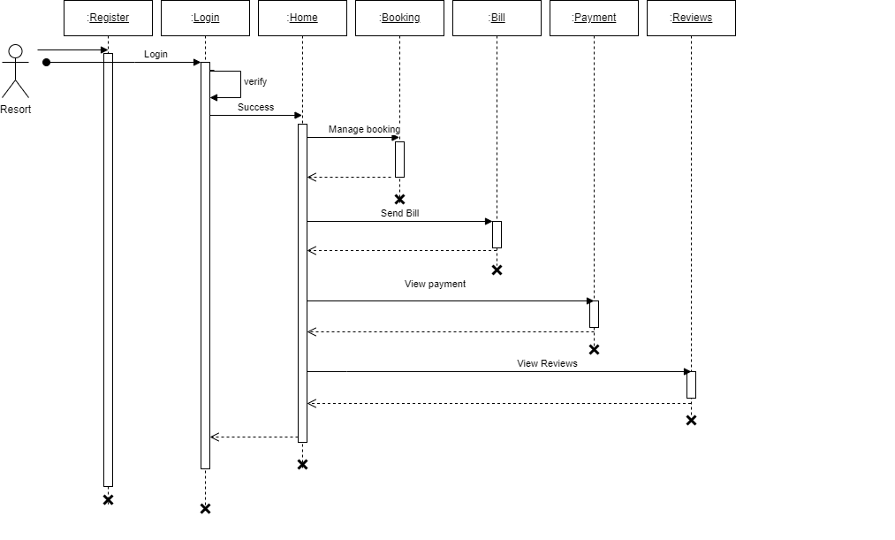

**Guide**

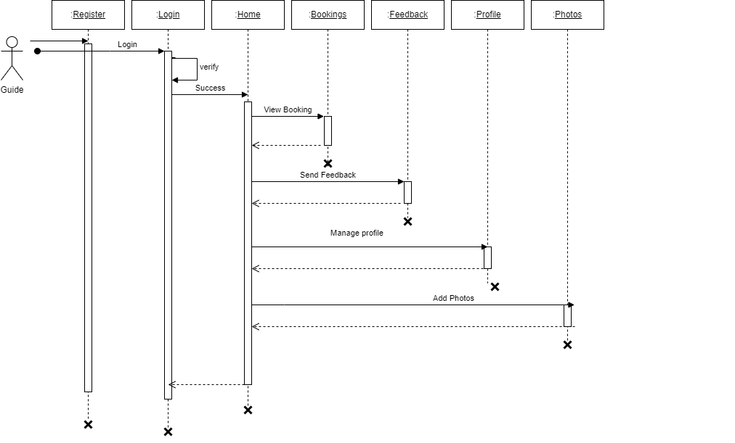

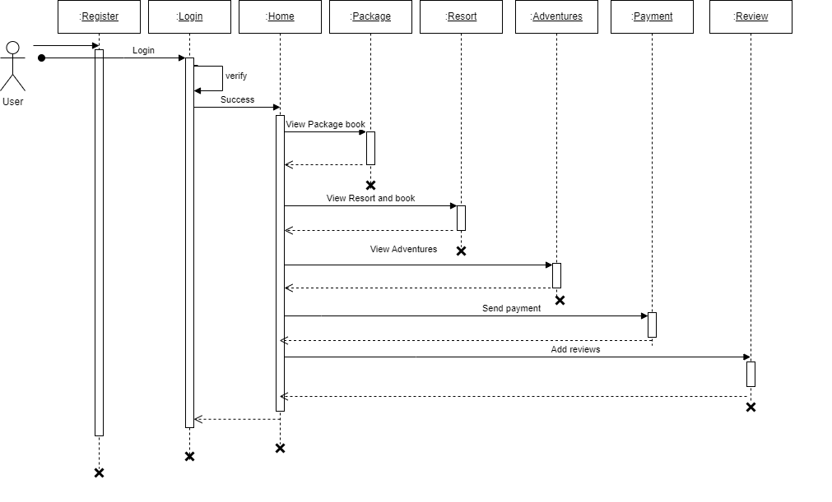 **User**

## SYSTEM DEVELOPMENT

**7. SYSTEM DEVELOPMENT**

System development is a series of operations to manipulate data to produce output from a computer system. The principal activities performed during the development phase can be divided into two major related sequences.

* External system development
* Internal system development

The major external system activities are:

* Implementation
* Planning
* Equipment acquisition
* Installation

### 7.1 Coding

The purpose of code is to facilitate the identification and retrieval of items of information. A code is an ordered collection of symbols designed to provide unique identification of an entity or an attribute. Code also shows interrelationship among different items. Codes are used to identify, access, sort, matching records. The code ensures that only one value of code with a single meaning is applied to give an entity or attribute as described in various ways.

#### .

### Node JS

Node js is an open-source, cross-platform JavaScript runtime environment that enables developers to build scalable and high-performance applications. It is built on top of the V8 JavaScript engine used by Google Chrome and provides an event-driven, non-blocking I/O model that makes it well-suited for real-time web applications. Node.js enables developers to write server-side applications using JavaScript, which is a popular and widely-used programming language on the web. It has a vast ecosystem of third-party packages and libraries that can be easily installed using the Node Package Manager (NPM). Node js applications can be run on various platforms such as Windows, Mac, and Linux.

### Express JS

Express.js is a minimal and flexible Node.js web application framework that provides a set of robust features for building web and mobile applications. It is one of the most popular and widely-used frameworks for Node.js, and is known for its simplicity and ease of use. Express.js provides a set of features for developing serverside web applications, including routing, middleware support, template engines, and much more. It also provides an easy-to-use API for interacting with databases such as MongoDB and MySQL, and supports a variety of templating engines, such as Pug, Handlebars, and EJS.

### Mongo DB

MongoDB is a popular document-oriented NoSQL database system that allows developers to store and manage large amounts of data in a flexible and scalable way. It is an open-source database that uses JSON-like documents with optional schemas, which makes it easy to work with and suitable for a variety of use cases. One of the key benefits of MongoDB is its ability to scale horizontally. This means that developers can add new servers to their database cluster as the amount of data or traffic increases, which allows the database to handle more requests and ensures that it can continue to perform well even as the application grows. MongoDB's query language supports a wide range of operations, including filtering, sorting, and aggregation. Developers can perform complex queries to retrieve and manipulate data efficiently. MongoDB allows the creation of indexes on any field within a document, enabling fast query execution. Indexes can significantly improve the performance of read operations, especially for frequently accessed fields. For applications that require geolocation data, MongoDB offers geospatial indexing and queries. This feature is valuable for location-based services, mapping applications, and proximity searches. MongoDB's document-oriented model accommodates diverse data structures within the same collection. This flexibility is advantageous when dealing with evolving or unstructured data, as schemas can be adjusted without downtime. MongoDB's replica sets ensure data redundancy and fault tolerance. Each replica set consists of multiple copies of data across different servers. If one server fails, the replica set automatically promotes a secondary node to primary, ensuring continuous availability.

.

**SYSTEM TESTING AND**

## IMPLEMENTATION

### 8.SYSTEM TESTING AND IMPLEMENTATION

Testing is vital to the success of the system. It makes a logical assumption that if all the parts of the system are correct, the goal will be successfully achieved in this projec**t**. It is the stage of implementation, which ensures that the system works accurately and effectively before the live operation commences. It is a confirmation that all are correct and an opportunity to show users that the system must be tested and show that the system will operate successfully and produce expected results under expected conditions. Software testing is a crucial element of software quality assurance and represents the unlimited review of specification, design and coding. Testing represents an interesting anomaly for the software. During the earlier definition and development phase, it was attempted to build the software from an abstract concept to implement.

Testing is a set of activities that can be planned in advance and conducted**.** Systematically, this is aimed at ensuring that the system works accurately and efficiently before live operations commences

#### 8.1Types of Testing

Different types of testing are:

* Unit testing
* Black Box Testing
* Validation Testing

**Unit testing**

Unit testing is usually conducted as part of a combined code and unit test phase of the software lifecycle, although it is not uncommon for coding and unit testing to be conducted as two distinct phases. All modules were tested individually as soon as they were completed and were checked for their correct functionality. Unit testing deals with testing a unit as a whole. This would test the interaction of many functions but confine the test within one unit. This testing is carried out during the programming stage itself. In this testing step each Module is found to be working satisfactorily as regard to the expected output from the module.

##### Black box testing

In black-box testing the structure of the program is not considered. Test cases are decided solely on the basis of the requirements or specifications of the program or module, and the internals of the module or the program are not considered for selection of test cases. In black-box testing, the tester only knows the inputs that can be given to the system and what output the system should give. This form of testing is also called functional or behavioural testing. The most obvious functional testing procedure is exhaustive testing. One criterion for generating test cases is to generate them randomly. There are no formal rules for designing test cases for functional testing.

##### Validation testing

In validation testing, the focus is on evaluating the software to ensure it meets the intended purpose and satisfies the requirements of stakeholders. Unlike black-box testing, which looks at the external behaviour, validation testing examines whether the software meets the user's needs and expectations. Validation testing is driven by the specific requirements and expectations outlined for the software. Test cases are designed based on these requirements to verify that the software functions as intended. Testers approach validation testing from the perspective of end-users. The goal is to validate that the software performs tasks and operations in a manner that aligns with user expectations and business objectives. Similar to black-box testing, functional validation focuses on the observable behaviour of the software. Testers interact with the software using various inputs to assess whether it produces the expected outputs and responses. Test cases in validation testing are often derived from real-world use cases and scenarios. These cases represent typical user interactions with the software, ensuring that common workflows and functionalities are thoroughly tested.

**SYSTEM MAINTENANCE**

### 9.SYSTEM MAINTENANCE

Maintenance is making adaptation of the software for external changes (requirements changes or enhancements) and internal changes (fixing bugs). When changes are made during the maintenance phase all preceding steps of the model must be revisited.

There are 3 types of maintenance:

* Corrective (Fixing bugs/errors)
* Adaptive (Updates due to environment changes)
* Perfective (Enhancements, requirements changes)

Maintenance is enigma of the system development. The definition of

the software maintenance can be given describing four activities that are undertaken after the program is released for use. The maintenance activity occurs since it is unreasonable to assume that software testing will uncover all in a large system. The second activity that contributes the definition of maintenance occurs since rapid changes are encountered in every aspects of computing. The third activity involves recommendation for new capabilities, modification to the existing functions and general enhancements when the software is used. The fourth maintenance activity occurs when software is changed to improve future maintainability or reliability.

## 

## FUTURE ENHANCEMENT

### 10.FUTURE ENHANCEMENT

In the future, JournEase wants to make its website even better. One idea is to use smart technology to suggest trips that match what people like and have done before. They might also add cool features like virtual guides to help users explore places before they go. JournEase could also partner with more travel companies to offer more choices and better deals. They might even use special technology to make sure all transactions are super safe. Plus, they could make planning trips more fun by adding games or rewards. By doing these things, JournEase hopes to make traveling easier and more enjoyable for everyone.

Additionally, JournEase could think about making their website easier to use for people with disabilities, like adding features that help them navigate better. They could also send updates about trips, like if there are any changes or problems, to keep travelers in the loop and help them stay safe. And to welcome even more people from different countries, JournEase might add more languages to their website. With these improvements, JournEase wants to be the go-to place for planning trips and making travel dreams come true for everyone.

## CONCLUSION

### 11.CONCLUSION

In short, JournEase wants to change how people plan and enjoy travel. They use new technology and ideas to make a website that anyone can use easily. They want to help people plan trips that fit their own likes and needs. JournEase gives suggestions, tools, and works with other companies to help travelers feel confident and have great experiences. They care about safety, making things easy to use, and making travel planning fun for everyone. They are always improving to make travel planning better and easier for everyone.

Also, JournEase wants to build a community of travelers. They want people to connect, share stories, and inspire each other to explore. They believe in including everyone and want to bring people together through travel. They work hard to make customers happy and keep making travel planning easier for everyone.

## APPENDIX

#### 12.APPENDIX

**Home Page**

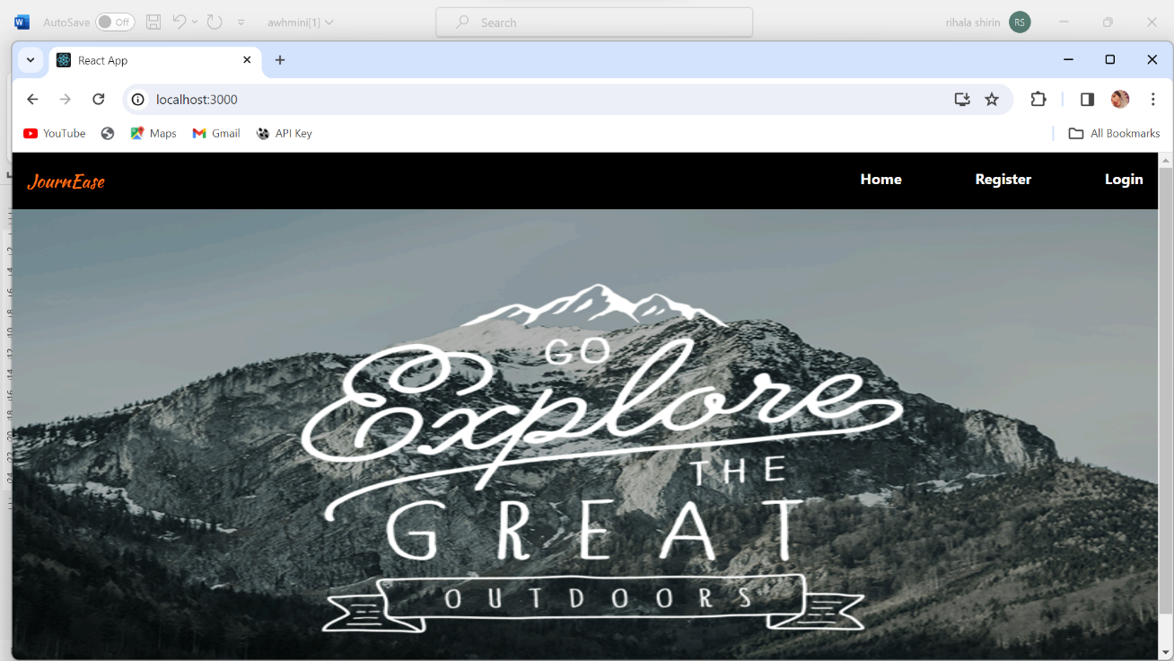

#### Login

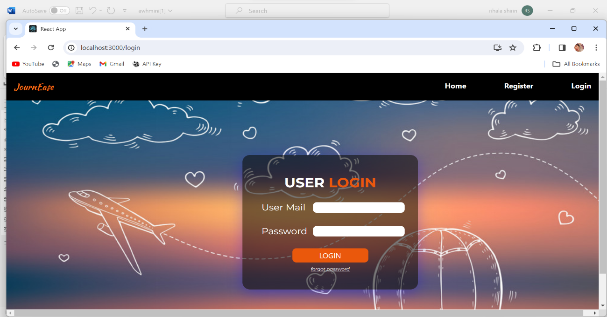

#### 

#### 

**Agency Registration Form**

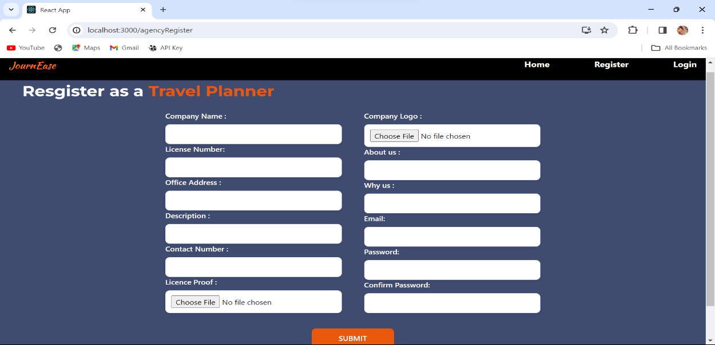

#### 

#### 

**Guide Registration Form**

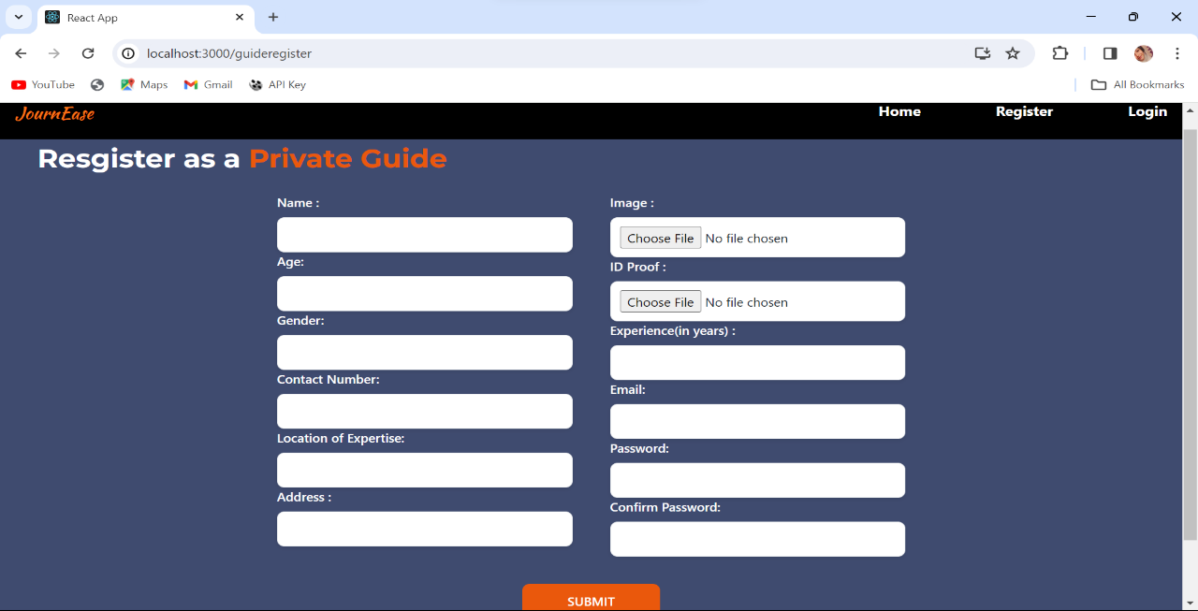

**Resort Registration Form**

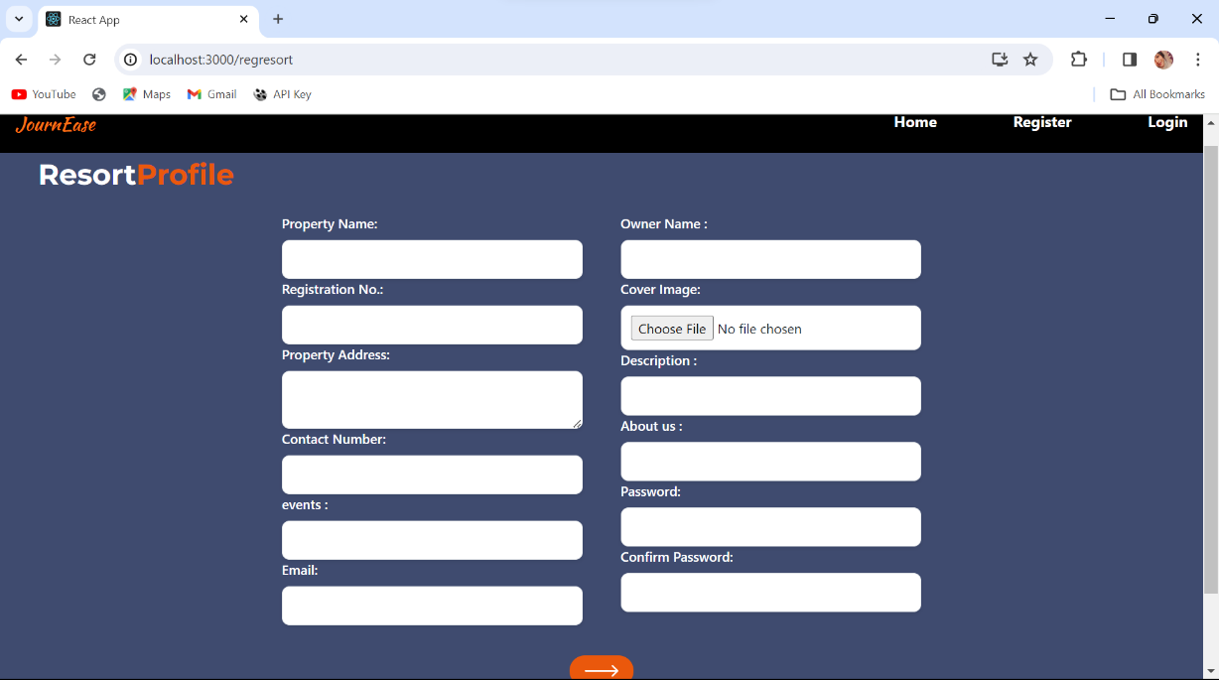

**User Registration Form**

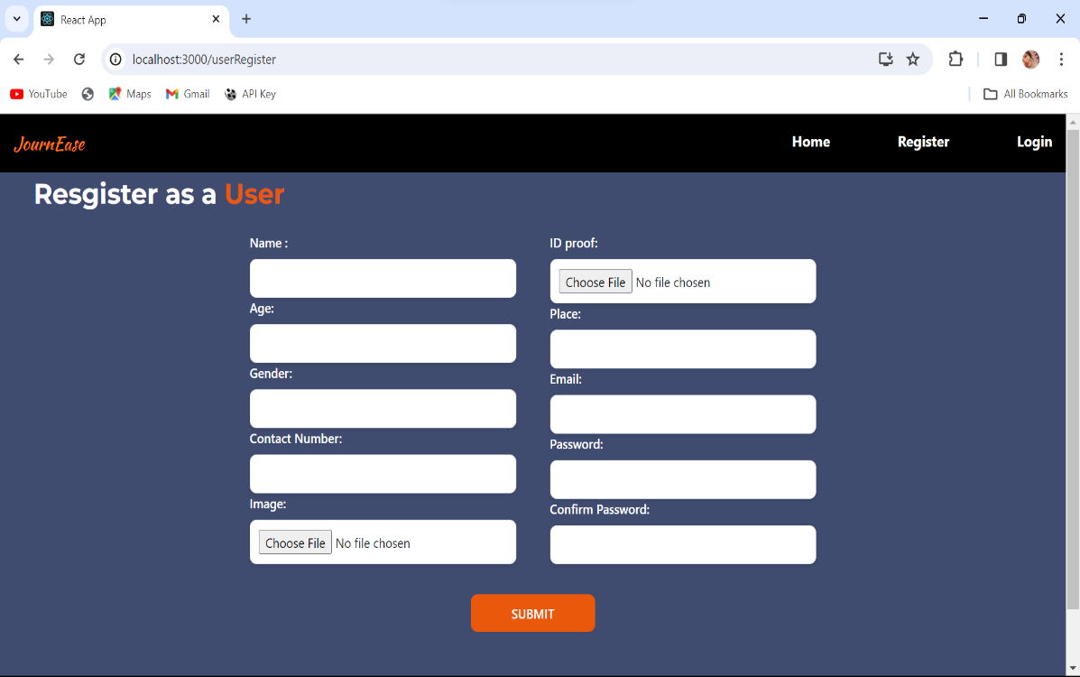

## Agency home page

## 

## add package

## 

**Add package information**

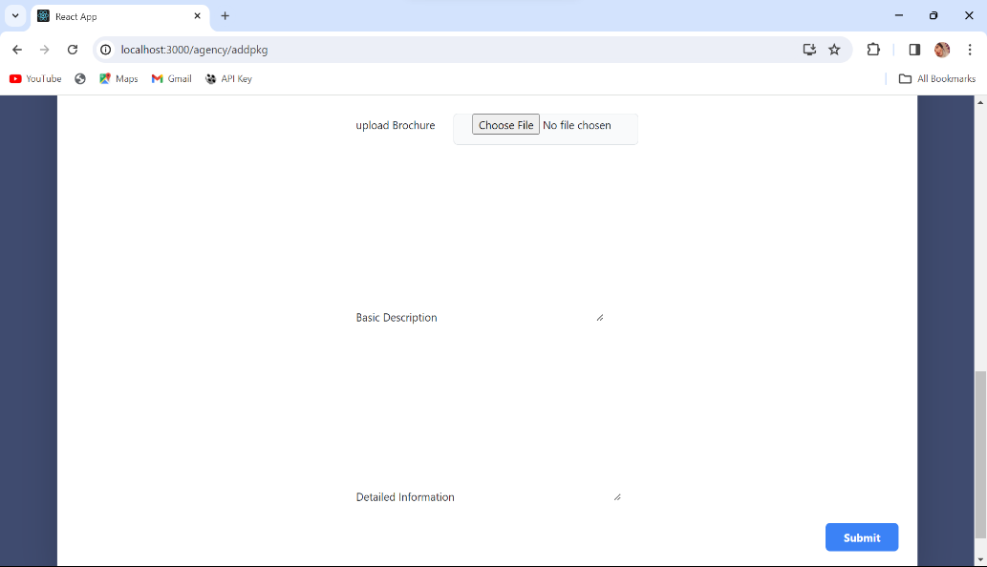

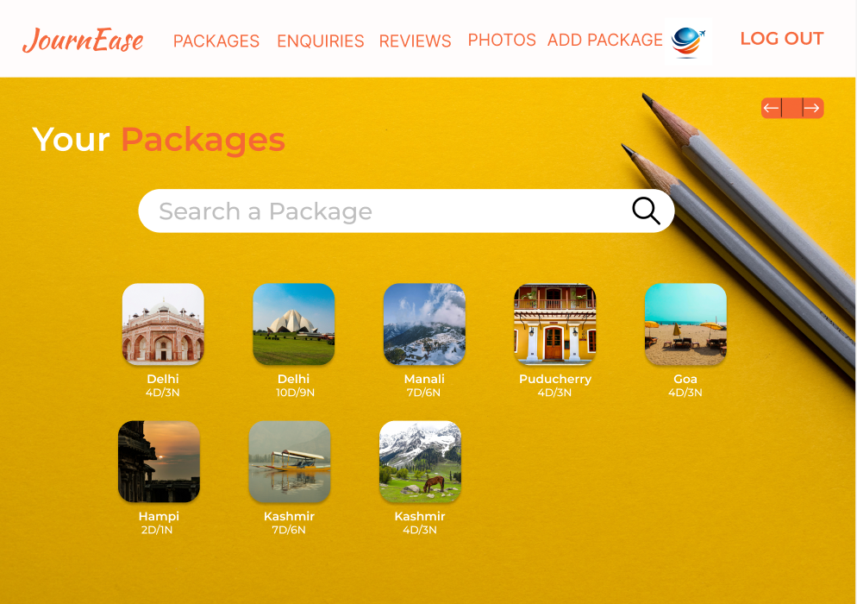

**View package**

## User homepage

## 

## View package Details

## 

## View booking

## 

## View booking detail

## 

## View Accomodation

## 

## View package user

## 

## View package details user

## 

## 

## View adventure

## 

## View payment

## 

## 

## Admin homepage

## 

## Manage request

## 

## Manage resort

## 

## View agency request

## 

## Manage Agency

## 

## Admin View package

## 

## Guide homepage

## 

## manage enquiry

## 

## Upload photos

## 

## Update profile

## 

## Add feedback

## 

## Make payment

## Choose guide

## 

## Add count

## 

## View agency details

## 

## View guide

## 

## Booking confirmation

## 

## Add review

## 

## View booked package

## 

## 

## User profile update

## 

## View notification

## 

## Add room facility

## 

## Add facilities

## 

## View facility

## 

## Update facility

## 

## View booking resort

## 

## View review resort

## 

## Resort profile updation

## 

## Agency profile updation

## 

## View reviews

## 

## View photos

## 

## 

## Edit package

## 

## Add adventure

## 

## 

## View selected adventure

## 

## View registered resorts

## 

## 

## Select adventures

## 

## View detail guide

## 

## 

## View review

## 

## Edit adventure

## 

## 

## User view reviews

## 

## View resort detail

## 

## View facility agency

## 

## User view room facility

## 

## User view resort detail

## 

## BIBLIOGRAPHY

### 

### 13.BIBLIOGRAPHY

#### Websites

1. *https://www.mongodb.com/docs*
2. https://expressjs.com/
3. *https://nodejs.org/en/docs*
4. *https://bootstrapmade.com*/*onepage-multipurpsode-bootstrap-template*
5. *https://developer.mozilla.org/en-US/docs/Web/HTML*
6. *https://developer.mozilla.org/en-US/docs/Web/CSS*

#### Books

1. *Thomas A Powell, Fritz Schneider, “JavaScript: The Complete*

*Reference”, 3rd Edition,*  *Tata McGraw Hill*

1. *Pro MERN Stack: Full Stack Web App Development with Mongo, Express, React, and Node" by Vasan Subramanian*
2. *Code complete: a practical handbook of software construction by Steve McConnell, Microsoft Press,2nd Edition(2004).*
3. *Full Stack Development with JHipster: Build scalable and maintainable web applications using the MERN stack" by Deepu K Sasidharan and Sendil Kumar N*
4. *Full Stack JavaScript: Learn Backbone.js, Node.js, and MongoDB" by Azat Mardan*